# SAVITRIBAI PHULE PUNE UNIVERSITY

PARVATIBAI GENBA MOZE COLLEGE OF ENGINEERING

**SECOND YEAR OF COMPUTER**

**ENGINEERING**



A Report On **“EMPLOYEE LEAVE MANAGEMENT SYSTEM”**

**SUBMITTED BY**

**RUTUJA TANAJI KAMBLE**

UNDER THE GUIDENCE OF

(Academy year 2022-2023)

**A PRELIMENERY REPORT ON**

**AN EMPLOYEE LEAVE MANAGEMENT SYSTEM**

**WEBSITE**.

SUBMITTED TO THE SAVITRIBAI PHULE PUNE UNIVERSITY, PUNE

IN THE PARTIAL FULFILLMENT OF REQUIREMENTS

FOR THE AWARD OF THE DEGREE

**BACHELOR OF ENGINEERING (COMPUTER ENGINEERING)**

##### SUBMITTED BY

**RUTUJA TANAJI KAMBLE**

**EXAM NO:**



## DEPARTMENT OF COMPUTER ENGINEERING

## PARVATIBAI GENBA MOZE COLLEGE OF ENGINEERING

**BAIF ROAD, WAGHOLI, PUNE 412207**

SAVITRIBAI PHULE PUNE UNIVERSITY

2023 -2024

## C:\Users\Kunal\Downloads\IMG-20170407-WA0019.jpg

**CERTIFICATE**

This is to certify that the report entitles

**“EMPLOYEE LEAVE MANAGEMENT SYSTEM”**

Submitted by

**RUTUJA TANAJI KAMBLE**

**EXAM NO:**

Is a bonafide student of this institute and the work has been carried out by her under the supervision of **Prof. Poonam Bhagat** and it is approved for the partial fulfillment of the requirement of Savitribai Phule Pune University, for the award of the degree of **Bachelor of Engineering** (Computer Engineering).

**(Prof. Poonam Bhagat)** **(Mr. S. D. Dhamdhere)**

Guide Head,

Department of Computer Engineering Department of Computer Engineering

**(Dr. N. S. Narawade)**

Principal,

Place : Pune

Date :

**ACKNOWLEDGEMENT**

This dissertation would not have been possible without the guidance and the help of several individuals who in one way or another contributed and extended their valuable assistance in the preparation and completion of this study.

First and foremost, I extend my deepest appreciation to mini project coordinator PROF.S.D.DHAMDHERE SIR, whose guidance, encouragementand expertise have been invaluable throughout his journey. Your insightful feedback and unwavering support have been instrumental in shapping the vision and executionof this project.

I would like to mention our sincere gratitude towards our principal, Dr. Navnath Narwade and HOD Prof. Shrikant Dhamdhere, Computer Department, for giving me the opportunity to carry out this project.

Furthermore I extend my appreciation to the faculty and staff of PARVTIBAI GENBA MOZE COLLEGE OF ENGINEERING for providi5ng a conductive learning environment and resources essential for the realization of this project.

Last but not least, I express my gratitude to my family for their unwaring support, understanding and encouragement throughout this endeavor.

Finally, I take this opportunity to mention our sincere thanks to one and all those who helped me directly or indirectly for the completion of my project.

**NAME OF STUDENT**

**RUTUJA TANAJI KAMBLE**

**ABSTRACT**

This project is aim is to develop an online employee leave management system that is of importance to either an organization. The Employee Leave Management System (ELMS) is an Intranet based application that can be accessed throughout the organization or a specified group/Dept. This system can be used to automate the workflow of leave applications and their approvals. The periodic crediting of leave is also automated. There are features like email notifications, automatic approval of leave, report generators etc.in this system. Leave Management application will reduce paper work and maintains record in more efficient way.

The use of paperwork in handling some of the processes could lead to human error, papers may end up in the wrong hands and not forgetting the facts that this is time consuming.

Basically the project describes how to manager for good performance and better service for the clients.

|  |  |  |  |  |  |
| --- | --- | --- | --- | --- | --- |
| **Sr. No.** | | | **Title of Chapter** | | **Page No.** |
| **01** | | | **Introduction** | | 9 |
|  | 1.1 | | Motivation | |  |
|  | 1.2 | | Problem Definition | |  |
| **02** | | | Literature Survey | | 10 |
| **03** | | | Software and Hardware Requirements | | 11 |
|  | | 3.1 | **Introduction** | |  |
|  | |  | 3.1.1 | Project Scope |  |
|  | |  | 3.1.2 | Assumptions and Dependencies |  |
|  | |  |  |  |  |
|  | | 3.2 | Functional Requirements | |  |
|  | |  | 3.2.1 | System Features |  |
|  | |  |  |  |  |
|  | | 3.3 | External Interface Requirements | |  |
|  | |  | 3.3.1 | User Interfaces |  |
|  | |  |  |  |  |
|  | | 3.4 | Nonfunctional Requirements | |  |
|  | |  | 3.4.1 | Safety Requirements |  |
|  | |  |  |  |  |
|  | | 3.5 | **System Requirements** | |  |
|  | |  | 3.5.1 | Software Requirements |  |
|  | |  | 3.5.2 | Hardware Requirements |  |
|  | |  |  |  |  |
| **04** | | | **Methodology/ Proposed system block diagram** | | 13 |
|  | | 4.1 | System Architecture | |  |
|  | | 4.2 | Proposed System Block Diagram/Flow chart | |  |
|  | |  |  | |  |
| **05** | | | Implementation Plan | | 14 |
| 5.1 | | | Algorithms/technology used | |  |
| 5.2 | | | Details of Modules/Execution Steps | |  |
|  | | |  | |  |
| **06** | | | Results | | 17 |
| 6.1 | | | Screenshots of Result | |  |
| **07** | | | Other Specification | | 18 |
|  | | 7.1 | Advantages and Disadvantages | |  |
|  | | 7.2 | Limitations | |  |
|  | | 7.3 | Applications | |  |
|  | | 7.4 | Challenges Faced | |  |
|  | |  |  | | 19 |
| **08** | | | **Conclusions & Future Work** | |  |
|  | | |  | |  |

**INTRODUCION**

This project is aimed at developing a web-based Leave Management System, which is of importance to either an organization or a college. The Leave Management system is an Intranet based application that can be accessed throughout the organization or a specified group/dept. This system can be used to automate the workflow of leave applications and their approvals. The periodic crediting of leave is also automated. There are features like notifications, cancellation of leave, automatic approval of leave, report generators etc. system.

Functional components of the project:

In this project, people should be get registered into the system. So that, Admin can able to approve the requests given by the requestor. In an organization, the hierarchy could be Principal/Manager/HOD/Faculty etc.

Following is a list of functionalities of the system (A person can able to):

• Login to the system through the first page of the application

• Change the password after logging into the system

• See his/her eligibility details (like how many days of leave he/she is eligible for .etc)

• Apply for leave, specifying the from and to dates, reason for taking leave, address for communication while on leave and his/her superior’s email id

• See his/her current leave applications and the leave applications that are submitted to him/her for approval or cancellation

• Approve/reject the leave applications that are submitted to him/her

• Withdraw his/her leave application (which has not been approved yet)

• Cancel his/her leave (which has been already approved). This will need to be approved by his/her Superior

• Get help about the leave system on how to use the different features of the system.

As soon as a leave application /cancellation request /approval /rejection/password-change is made by the person, an automatic massage should be sent to the person and his superior giving details about the action.

The number of days of leave (as per the assumed leave policy) should be automatically credited to everybody and a notification regarding the same be sent to them automatically.

An automatic leave-approval facility for leave applications which are older than 2 weeks should be there. Notification about the automatic leave approval should be sent to the personas well as his superior.

\***MOTIVATION:**

• The primary concern of this Employee Management System project is to make a system which will help any organization to maintain the employee’s information.

• It will take lots of time to maintain the record manually.

• Employees are not able to see their leave status.

\***PROBLEM STATEMENT:**

Overview of Problem

The use of paperwork in handling some of the processes could lead to human error, papers may end up in the wrong hands and not forgetting the facts that this is time consuming. A few current systems lack employee self-service meaning employees are not able to access and manage their personal information directly without having to go through their HR department or their managers. Another challenge is that multi-national companies will have all the employee information stored at the headquarters of the company making it difficult to access the employee information from remote place when needed at short notice. The project is aimed at setting up an employee’s information system about the status of the employee, the educational background, and the work experience to help monitor the performance and achievement of the employee through password protected system.

**LITERATURE SURVEY**

This system helps organizations develop the system and manage their employees. The employee management system is designed to save money, time and effort. Simplifying the process of maintaining records can be very helpful in an organization. Employees are the backbone of any organization, so it is necessary to keep them happy. This concept brings transparency to their wage calculations. It also makes it easier for you to work with HR so you can focus on other tasks. This employee leave management system manages the overall performance and aspects of employees within the organization.

The organization can maintain computerized records without redundant entries. That means that one need not be distracted by information that is not relevant, while being able to reach the information. The aim is to automate its existing manual system by the help of computerized equipment’s and full-fledged computer software, fulfilling their requirements, so that their valuable data/information can be stored for a longer period with easy accessing and manipulation of the same.

If the superior officers reject the leave, a reason for rejecting the leave must be entered into the system and the employee who requested the leave will be notified and if the leave request requires a higher superior officer for approval before notifying the employee, the respective officer will be notified.

Basically the project describes how to manage for good performance and better

Services for the clients.

**SOFTERWARE AND HARDWARE REQUIREMENTS**

### **Scope:**

It may help collecting perfect management in details in a very short time, the collection will be obvious, simple and sensible. It will help a person to know he management of passed year perfectly and vividly. It also help in current all works relative to Employee Leave Management System. It will be also reduce the cost of collecting the management and collection procedure will go on smoothly. The best way to achieve this is to check the rooster to approve or reject a leave after evaluating the impact on the work.

### 1. Significantly less paperwork

One of the benefits of using software tools is the reduction of dull and repetitive tasks. An online leave management system offers integration and automation that significantly reduces the amount of paperwork. A paper trail of leave management is cumbersome as well as a deterrent to the environment.

Printing and filling forms is a headache for employees and record keeping of such files is painstaking for employers. With a few clicks, the entire process of leave application till approval is completed when you have an employee leave management system at work.

### 2. Auto-update leave balance

There is no point in buying an HR management software if HR staff has to compute and update leave data manually. The entire process of tracking leave history and accessibility to the managers and employees is automated.

### 3. Real-time information and updates

When approving leaves or applying for leaves it is important to have information if it is the right time to approve or apply for a leave. Unless there is a leave management system that provides information in real-time, it is going to be difficult.

Also, outdated information can result in conflicts between the managers and employees because it can cause rejection of applications of employees who need a vacation. Real-time updates are also important to avoid situations where too many permissions are granted resulting in understaffing.

### 4. Save the time of administration

The benefits of a leave management system for administration are equally important. The total elimination of repetitive tasks makes leave management a lot faster and more convenient. Modern leave management systems can easily be integrated with other office tools.

Such a level of automation saves a lot of time for administration and offers a more comprehensive ecosystem for employee management.

### 5. Transparent and accurate

The online leave management system provides a comprehensive view of all leaves, either planned or unplanned in a single dashboard. For employers, it provides a tool to have accurate data on employees abusing leave policies or underusing their vacations.

This transparency helps spot productivity leaks and tackle problems related to absenteeism.

### 6. Easily Manage Holidays

An automated leave management system can help employers to manage the holiday and vacations of their employees more efficiently. With the help of the leave management system, your employees will be able to mark any leave of absence like holidays, sick leave, etc. Moreover, your employees will have access to their holiday leave at any moment.

**SOFTWARE-REQUIREMENTS:**  One of the most difficult tasks is that, the selection of the software, once system requirement is known is determining whether a particular software package fits the requirements. After initial selection further security is needed to determine the desirability of particular software compared with other candidates. This section first summarizes the application requirement question and then suggests more detailed comparisons

.•Operating System -------- Windows 11

•Browser -------- Chrome

•Web/Application Server -------- apache web server

•Database Server -------- MySQL

•Database Connectivity -------- JDBC

•Other Tools & Technologies -------- PHP, HTML

**HARDWARE REQUIREMENTS:**

The selection of hardware is very important in the existence and proper working of any software. In the selection of hardware, the size and the capacity requirements are also important. The Web Based Manufacturing System can be efficiently run on Pentium system with at least 128 MB RAM and Hard disk drive having 20 GB. Floppy disk drive of 1.44 MB and 14inch Samsung color monitor suits the information system operation.(A Printer is required for hard copy output).

•Pentium processor -------- 233 MHZ or above

•RAM Capacity --------128MB

•Hard Disk -------- 20GB

•Floppy disk -------- 1.44 MB

•CD-ROM Drive -------- 32 HZ

•KEYBOARD -------- 108 Standard

PROPOSED SYSTEM:

The development of the new system contains the following activities, which try to automate the entire process keeping in view of the database integration approach.

•User friendliness is provided in the application with various controls.

•The system makes the overall project management much easier and flexible.

•Readily upload the latest updates, allows user to download the alerts by clicking the URL.

EXISTING SYSTEM:

•All Work are done Manually.

•Cannot Upload and Download the latest updates

.•No use of Web Services and Remoting.

•Risk of mismanagement and of data when the project is under development.

•Less Security.

•No proper coordination between different Applications and Users.

•Fewer Users – Friendly.

**METHODOLOGY**

* ARCHITECTURE DIAGRAM:

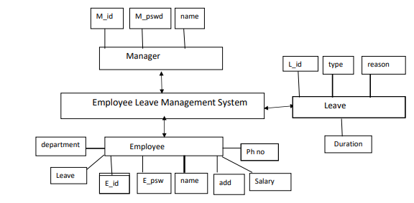

* 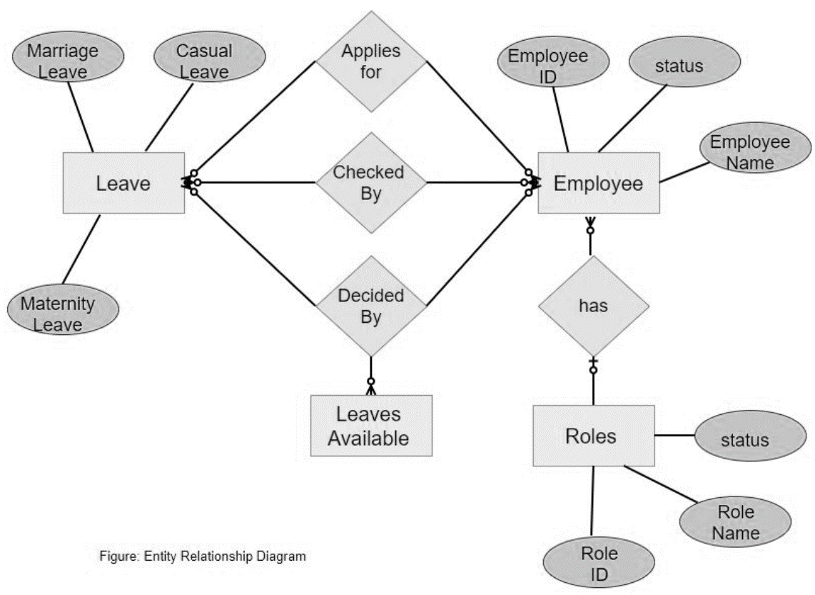Entity relationship diagram:
* Data Flow Diagram :

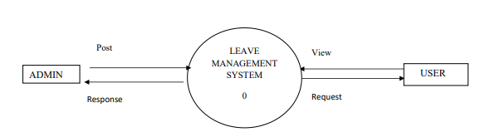

* UML USE CASE DIAGRAM

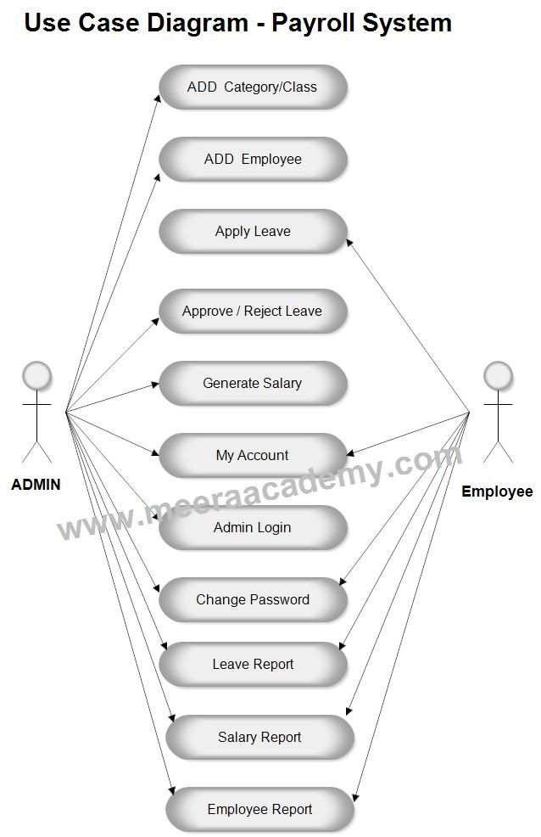 Description: A use case diagram is a dynamic or behaviour diagram in UML. Use case diagrams model the functionality of a system using actors and use cases. Use cases are a

set of actions, services, and functions that the system needs to perform.

**CODEING LANGUAGE USE:**

**INTRODUCTION TO PHP**

**PHP**

Hypertext Preprocessor, is a widely used, general-purpose scripting language that was originally designed for web development, to produce dynamic web pages. It can be embedded into HTML and generally runs on a web server, which needs to be configured to process PHP code and create web page content from it. It can be deployed on most webservers and on almost every operating system and platform free of charge. PHP was originally created by Rasmus Lerdorf in 1995 and has been in continuous development ever since. The main implementation of PHP is now produced By The PHP Group and serves as the de facto standard for PHP as there is no formal specification. PHP is free software released under the PHP License, which is incompatible with the GNU General Public License (GPL) because of restrictions on the use of the term PHP. PHP has evolved to include a command line interface capability and can also be used in standalone graphical applications.

USAGE

PHP is a general-purpose scripting language that is especially suited for web development. PHP generally runs on a web server. Any PHP code in a requested file is executed by the PHP runtime, usually to create dynamic web page content. It can also be used for command-line scripting and client-side GUI applications. PHP can be deployed on most web servers, many operating systems and platforms, and can be used with many relational database management systems. It is available free of charge, and the PHP Group provides the complete source code for users to build, customize and extend for their own use.

**HTML**

HTML, which stands for Hyper Text Markup Language, is the predominant markup language for web pages. It provides a means to create structured documents by denoting structural semantics for text such as headings, paragraphs, lists etc as well as for links, quotes, and other items. It allows images and objects to be embedded and can be used to create interactive forms. It is written in the form of HTML elements consisting of "tags" surrounded by angle brackets within the web page content. It can include or can load scripts in languages such as JavaScript which affect the behavior of HTML processors like Web browsers; and Cascading Style Sheets (CSS) to define the appearance and layout of text and other material. The W3C, maintainer of both HTML and CSS standards, encourages the use of CSS over explicit presentational markup. Hyper Text Markup Language (HTML) is the encoding scheme used to create and format a web document. A user need not be an expert programmer to make use of HTML for creating hypertext documents that can be put on the internet.

CSS (Cascading Style Sheets):

* CSS is the style sheet language used for describing the presentation of a document written in HTML.
* It enables web developers to control the layout, typography, colors, and other visual aspects of a web page.
* CSS works by targeting HTML elements and applying styles to them using selector and declarations.

Certainly! HTML (Hypertext Markup Language) and CSS (Cascading Style Sheets) are fundamental technologies used for creating web pages and designing their appearance.

**JAVASCRIPT**

JavaScript is an object-oriented scripting language used to enable programmatic access to objects within both the client application and other applications. It is primarily used in the form of client-side JavaScript, implemented as an integrated component of the web browser, allowing the development of enhanced user interfaces and dynamic websites. JavaScript is a dialect of the ECMAScript standard and is characterized as a dynamic, weakly typed, prototype-based language with first-class functions. JavaScript was influenced by many languages and was designed to look like Java, but to be easier for non-programmers to work with. JavaScript uses prototypes instead of classes for inheritance. It is possible to simulate many class-based features with prototypes in JavaScript. Functions double as object constructors along with their typical role. Prefixing a function call with new creates a new object and calls that function with its local this keyword bound to that object for that invocation. The constructor's prototype property determines the object used for the new object's internal prototype. JavaScript's built-in constructors, such as Array, also have prototypes that can be modified.

**MySQL:**

MySQL, the most popular Open Source SQL database management system, is developed, distributed, and supported by Oracle Corporation.

• MySQL is a database management system.

A database is a structured collection of data. It may be anything from a simple shopping list to a picture gallery or the vast amounts of information in a corporate network. To add, access, and process data stored in a computer database, you need a database management system such as MySQL Server. Since computers are very good at handling large amounts of data, database management systems play a central role in computing, as standalone utilities, or as parts of other applications.

• A large amount of contributed MySQL software is available.

MySQL Server has a practical set of features developed in close cooperation with our users. It is very likely that your favorite application or language supports the MySQL Database Server.

Implements SQL functions using a highly optimized class library that should be as fast as possible. Usually there is no memory allocation at all after query initialization. Provides the server as a separate program for use in a client/server networked environment, and as a library that can be embedded (linked) into standalone applications. Such applications can be used in isolation or in environments where no network is available.

**Data Types**

Many data types: signed/unsigned integers 1, 2, 3, 4, and 8 bytes long, FLOAT, DOUBLE, CHAR, VARCHAR, BINARY,VARBINARY, TEXT, BLOB, DA TE, TIME, DATETIME, TIMESTAMP, YEAR, SET, ENUM, and Open GIS spatial types.

**ALGORITHM**

Designing an algorithm for a leave management system involves outlining the steps needed to handle various aspects of managing employee leave requests. Here's a basic outline of such an algorithm:

1. Input:

* Employee detail (e.g., name, ID).
* Leave request details (e.g., type of leave, start date, end date).
* Current leave balance for the employee.

1. Validation:

* Check if the employee is eligible for the requested type of leave.
* Verify if the requested leave dates are within the employee's available leave balance.
* Ensure that the requested leave dates do not conflict with any existing leave requests or company policies.

1. Update profile:

* Deduct the approved leave duration from the employee's leave balance.

1. Notification:

* Notify the employee that their leave request has been approved or denied.
* If approved, provide details of the approved leave dates.

1. Manager Approval:

* If the leave management system requires manager approval, send the leave request to the designated manager for review.
* The manager reviews the request and either approves or denies it.
* If approved, proceed with updating the leave balance and notifying the employee.
* If denied, notify the employee of the denial reason.

6. .Record Keeping:

* Maintain a record of all leave requests, including their status (approved, pending, denied) and any comments or reasons for denial.

7. User Interaction:

* Provide an interface for employees to submit leave requests and view their leave balances and request status.
* Provide an interface for managers to review and approve/deny leave requests.

8. Exception Handling:

* Handle any errors or exceptional situations gracefully, such as invalid input or system failures.

9. Reporting:

* Generate reports on leave usage, employee attendance, and other relevant metrics for HR and management purposes.

This algorithm provides a basic framework for handling leave requests within a leave management system. Depending on the specific requirements and complexity of the system, additional features and functionalities may need to be incorporated.

**RESULT AND DISCUSSION**

**HOMEPAGE FOR EMPLOYEE LEAVE MANAGEMENT SYSTEM**

DESCRIPTION: This is the home page for employee management system, form where employee, admin and Employee can login. and admin or Employee can recover the password.

**CODING FOR HOMEPAGE OF EMPLOYEE LEAVE MANAGEMENT SYSTEM:**

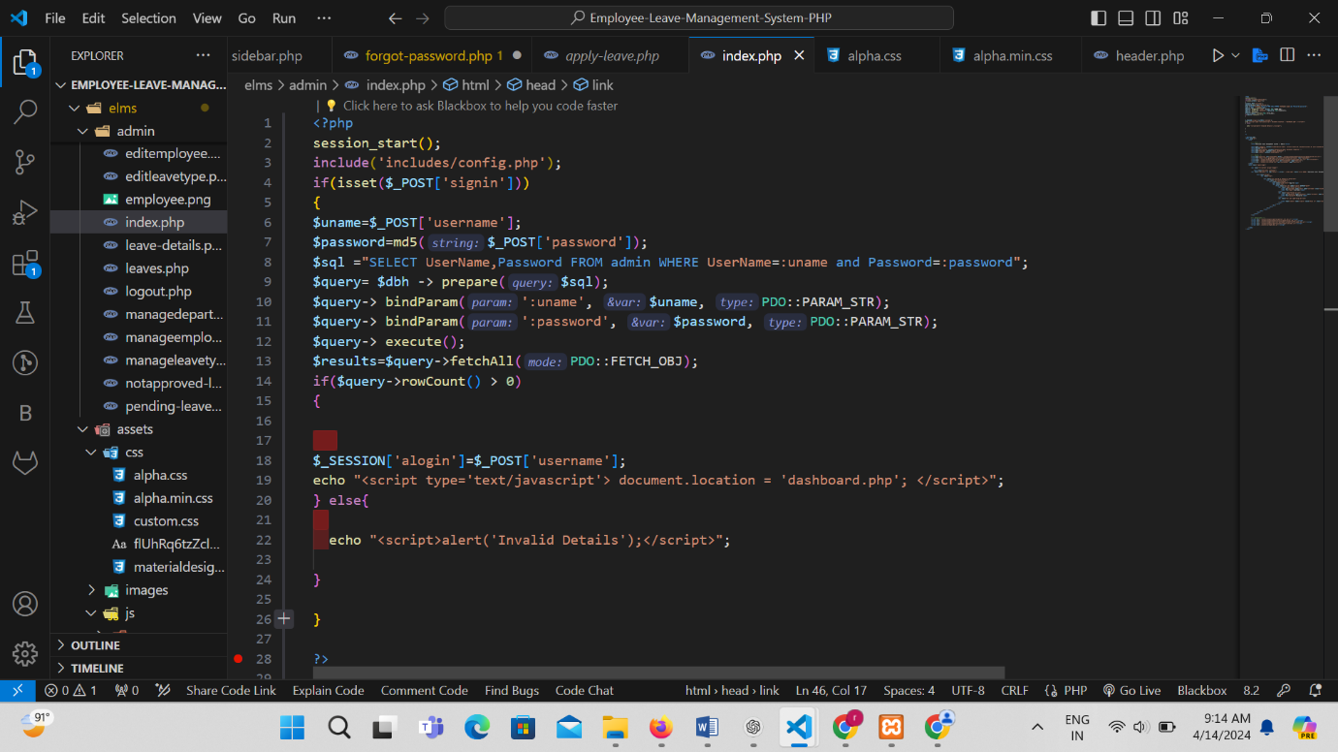

**OUTPUT FOR HOMEPAGE:**

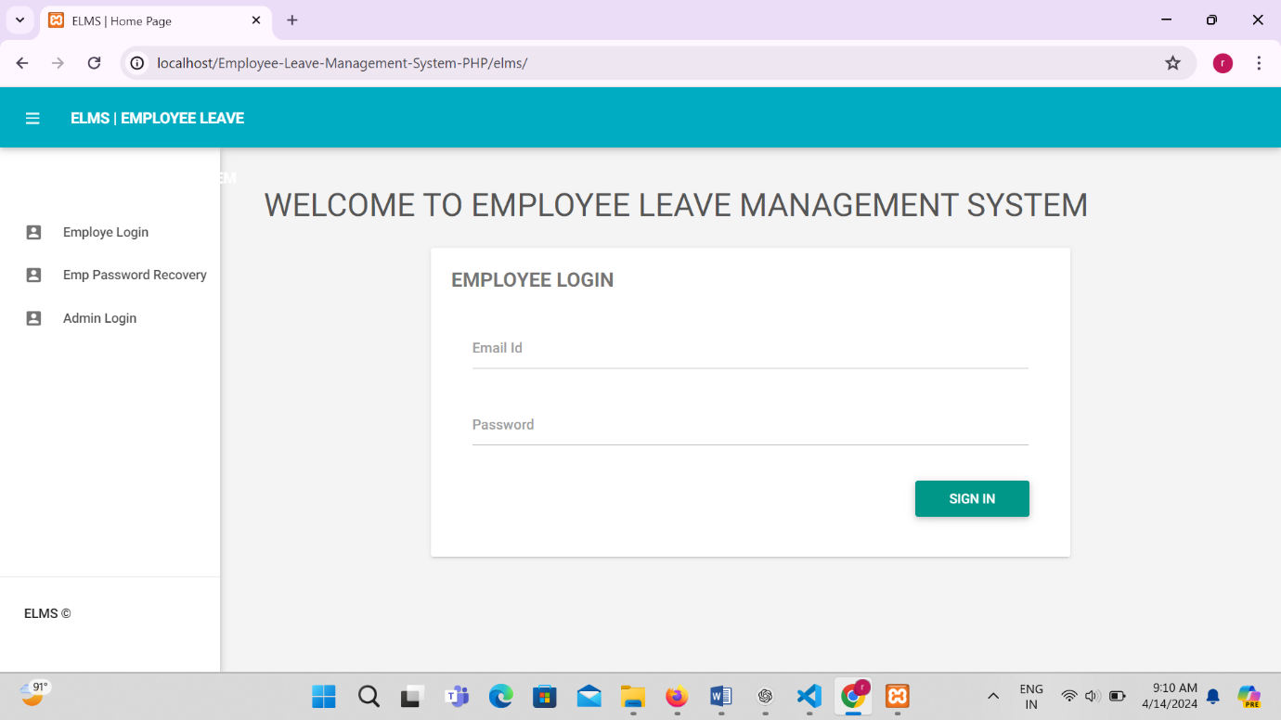

**LOGIN PAGE FOR ADMIN**:

DESCRIPTION: This is an Admin login page from where any admin can login to the website by entering the correct username and password.

**CODING FOR EMPLOYEE LOGIN PAGE**

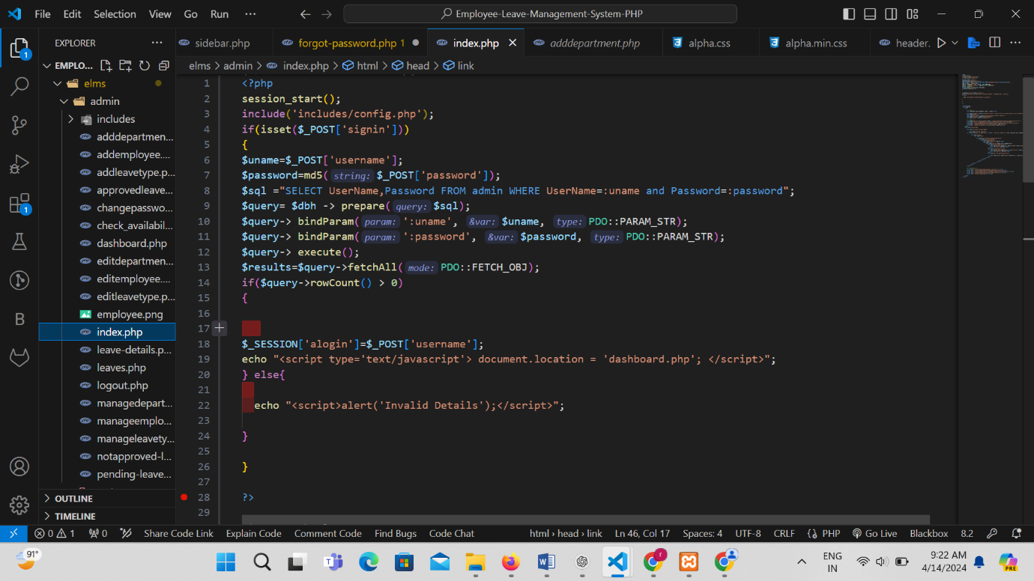

**OUTPUT FOR EMPLOYEE LOGIN:**

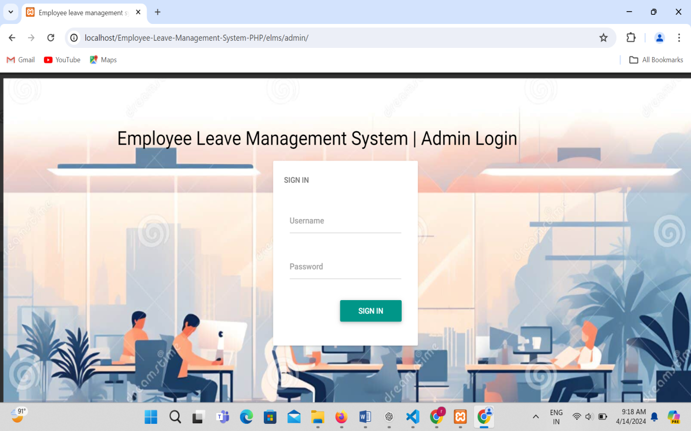

**LOGIN PAGE FOR EMPLOYEE**

DESCRIPTION: This is an employee login page from where any employee can login to the website by entering the correct username and password.

**CODING FOR EMPLOYEE LOGIN PAGE**

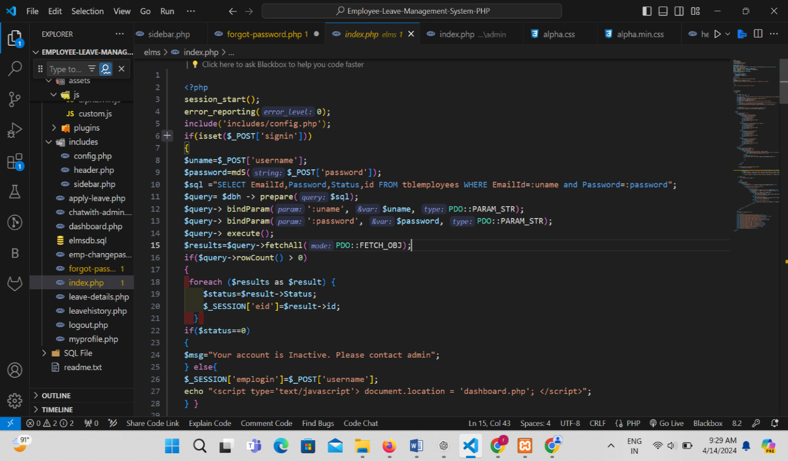

**OUTPUT FOR EMPLOYEE LOGIN:**

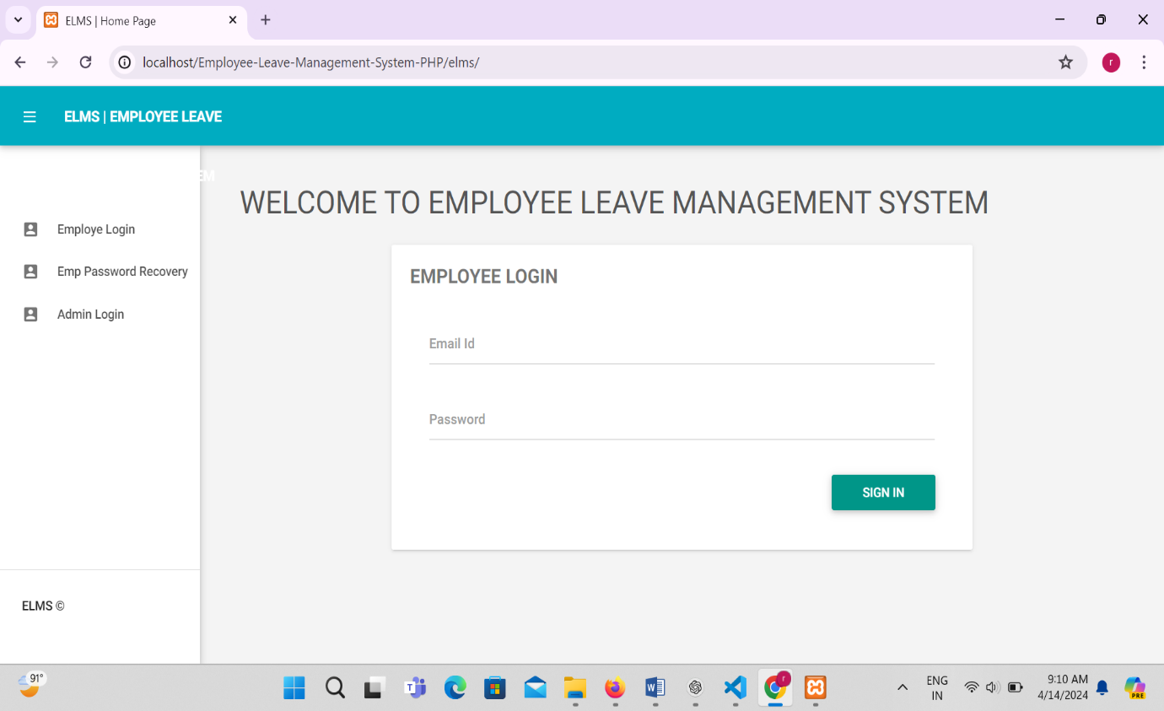

**EMPLOYEE PASSWORD RECOVERY**

DESCRIPTION: Here employee can recover the password by entering the Employee details like employee id, email id.

**CODING FOR EMPLOYEE PASSWORD RECOVERY**

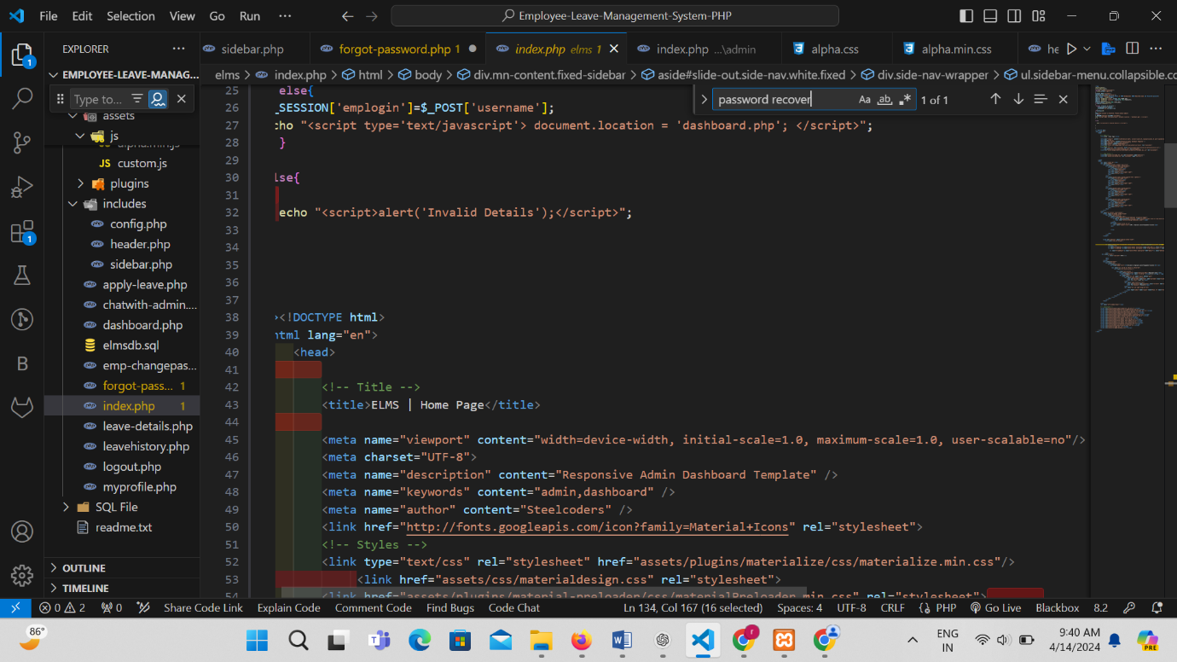

**OUTPUT FOR EMPLOYEE PASSWORD RECOVERY:**

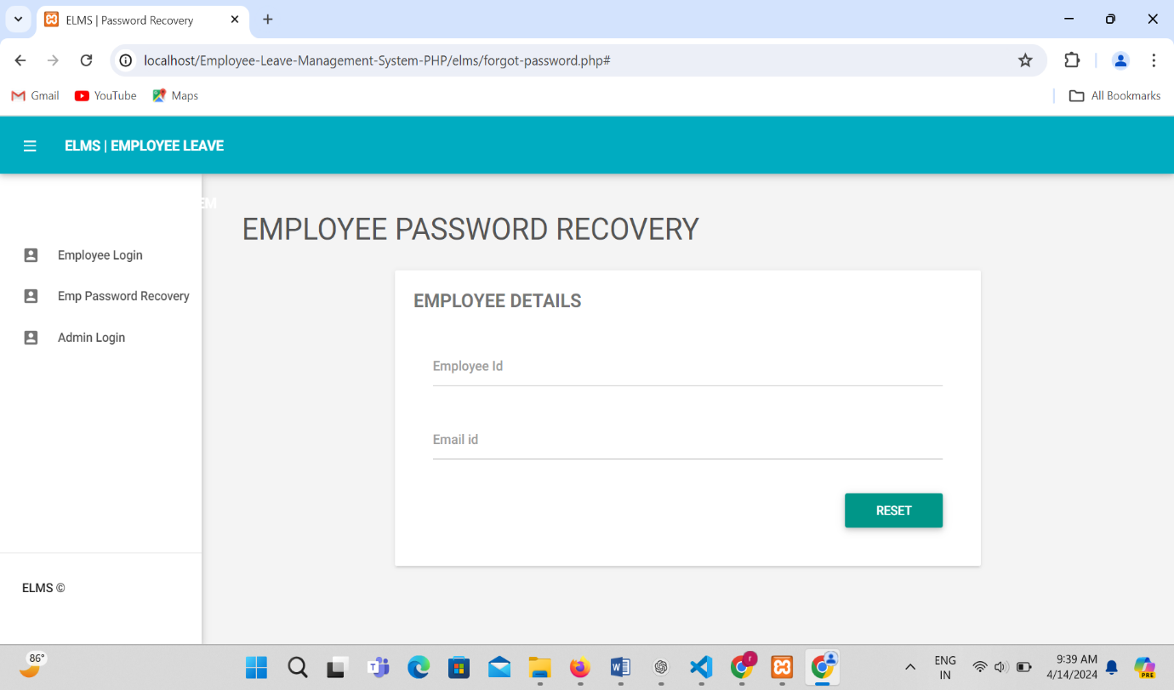

### **Advantages**

Online leave management systems help to instantly retrieve accurate information about employees' leaves and the number of leaves taken, leave trends and leave balances. It's a one-step process compared to manually browsing through the vacation register pages to filter out the information you need. It can be integrated with online payroll software to easily create accurate payroll statements, triggering a series of benefits in sequence.

Since all information is available online, the leave administration becomes all the more transparent. Both managers and employees have access to the records of the latter, which explains why a leave was approved or rejected.

Obtain accurate information about the maximum and minimum number of days of leave that can be taken by anyone before requesting leave.

The online leave management system can be customized to reflect the company's vacation policies and regulations, making it easier to avoid preferential treatment when requesting or approving leave.

It keeps managers informed of the availability of team members to meet project deadlines. During key project periods, managers can access this information and make decisions without wasting time.

It is crucial for employers to comply with local labor laws regarding employee leave. Failure to comply with these laws can cause major problems for the company. By implementing an online leave system, managers can ensure that all laws are strictly enforced.

By giving employees easy access to their vacation history and availability, it is easy to improve accuracy and build discipline within the company. This helps to better manage employee attendance, as everyone is aware of the consequences if they do not comply with the company's leave policy.

The above benefits have been largely responsible for replacing old traditions of using registers or maintaining spreadsheets on stand-alone machines. The online leave management system helps to save time and money in a competitive business environment.

### Disadvantages

Cost may not be a big problem for larger companies, but it can be a big problem for smaller companies. There are many costs associated with online leave management systems, such as acquisition and maintenance costs. If they don't fit into the budget of these companies, they may have to make do with inferior software.

Security is another concern when it comes to online leave management systems. They should be designed to prevent unauthorized access to sensitive and confidential data.

**CONCLUSION**

It has been a great pleasure for me to work on this exciting and challenging project. This project proved good for me as it provided practical knowledge of not only programming in html and css web based application and no some extent Windows Application and SQL Server, but also about all handling procedure related with “employee leave management system”. It also provides knowledge about the latest technology used in developing web enabled application and client server technology that will be great demand in future. This will provide better opportunities and guidance in future in developing projects independently.

Further upgradation of the Leave Management System for various types of organizations with multiple hierarchies can help in reducing paperwork, help achieve error free tabulation and calculation of leaves.

**REFERENCE**

* <https://chat.openai.com/>
* https://www.google.com
* <https://www.youtube.com/>
* https://www.w3schools.com/

**FUTURE IMPROVEMENT:-**

• This system being web based and an undertaking of cyber security division needs to be thoroughly tested to find out any security gaps.

• A console for the data center may be made available to allow the personnel to monitor on the site which cleared for hosting during a particular period.

• Moreover, it is just a beginning, further the system may be utilized in various other types of auditing operation viz network auditing or similar process workflow based application.